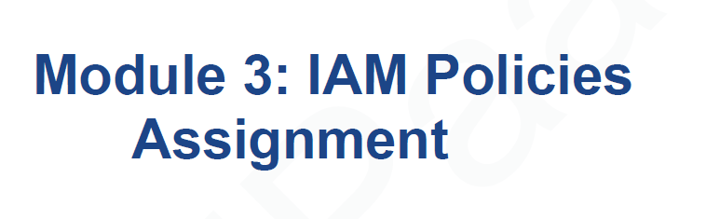

**Problem Statement:**

You work for XYZ Corporation. To maintain the security of the AWS account and

the resources you have been asked to implement a solution that can help easily

recognize and monitor the different users.

**Tasks To Be Performed:**

1. Create policy number 1 which lets the users to:

a. Access S3 completely

b. Only create EC2 instances

c. Full access to RDS

2. Create a policy number 2 which allows the users to:

a. Access CloudWatch and billing completely

b. Can only list EC2 and S3 resources

3. Attach policy number 1 to the Dev Team from task 1

4. Attach policy number 2 to Ops Team from task 1

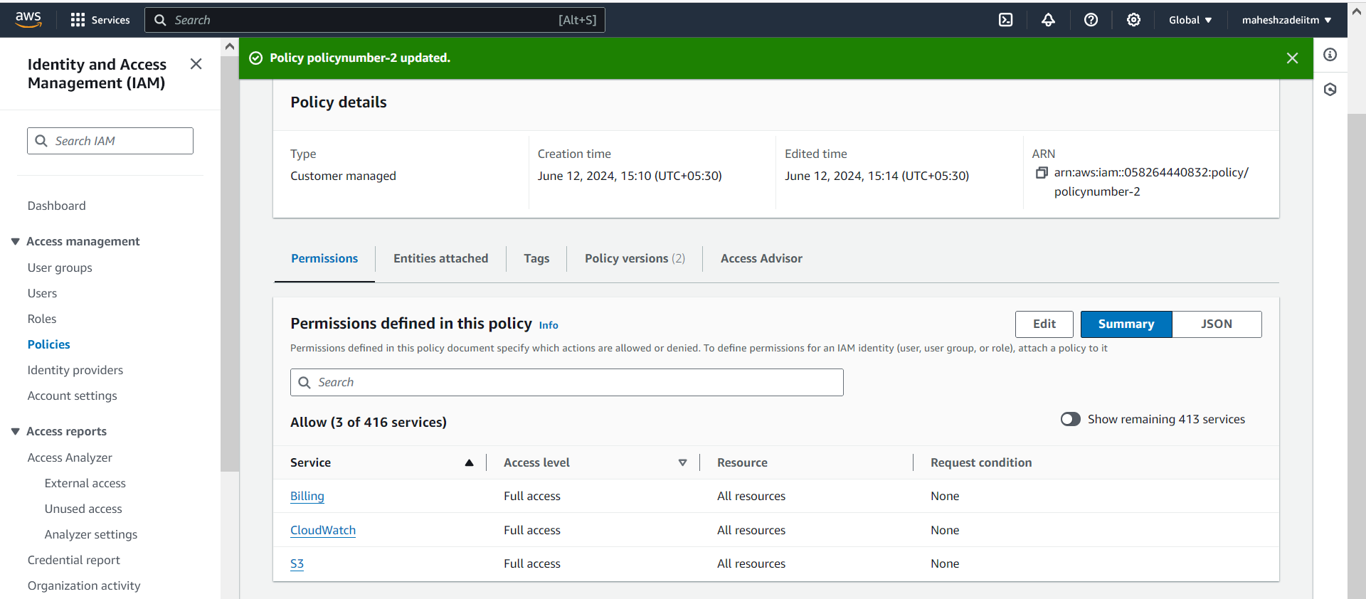

Policy attached

Policy attached to ops team

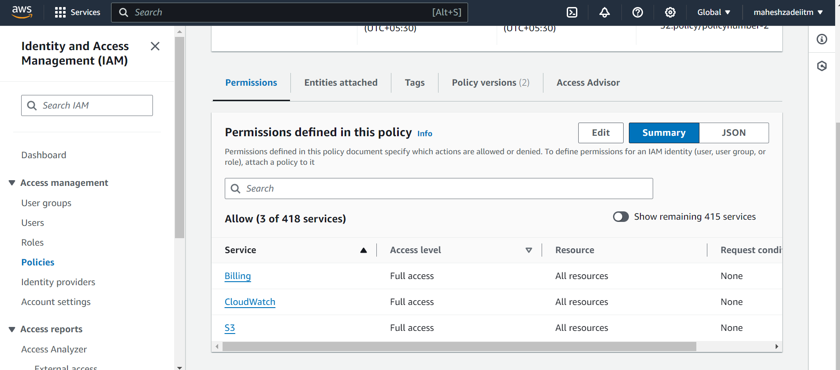

EC2 Permission added

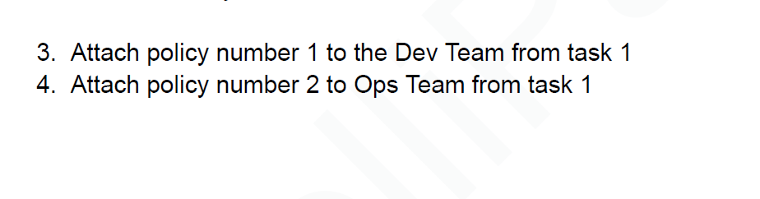

Click on attach policy

For the next task, let’s Create a role which only lets user1 and user2 from task 1 to have complete access to VPCs and DynamoDB.

Click on Roles 🡪 Create Role

Click on next

Search in the policies and add **AmazonVPCFullAccess** and **AmazonDynamoDBFullAccess**. Click on Next.

Name: VPCandDynamoDBFullAccessRole 🡪 Click on Create Role

Search in the policies and add **AmazonVPCFullAccess** and **AmazonDynamoDBFullAccess**. Click on Next.

Name: VPCandDynamoDBFullAccessRole 🡪 Click on Create Role

Click on create Rule

Now we need to add users to this role.

Go to Roles 🡪 VPCandDynamoDBFullAccessRole

Policy updated

Copy Swicth role url

<https://signin.aws.amazon.com/switchrole?roleName=VPCandDynmaodbfullaccess&account=maheshzade>

Paste in browser

Click on Switch Role

Also it is able to fetch the table details and showing that **there are no tables in this account** and no permission errors.

Similary navigate to VPC and see that it is fully accessible.

It is able to fetch the details and no permission errors

Summary

1. Created users and groups. Added those users to the appropriate groups.
2. Created 2 policies for different use cases. Attached them to the respective groups asked in the problem statement.
3. Created a role to allow 2 users to have complete VPC and DynamoDB access.
4. Logged in to User1 (Dev1) and verified that it is working as expected.

Thanks you.